All Saints’ North Hillingdon
7th December 2025
2nd Sunday of Advent

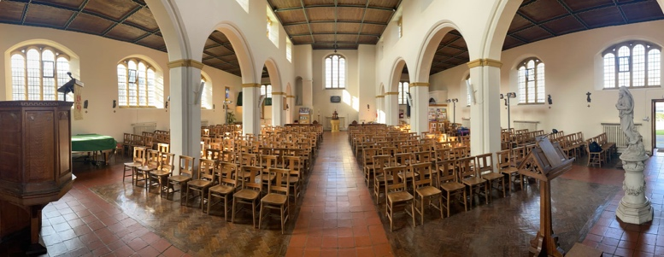

In the dark times of the nation, Isaiah foresees a messiah, a ‘shoot’ from the stump of the tribe Jesse, a righteous ruler full of the Spirit, who will bring hope, justice, peace and the transformation of creation itself; ‘the earth will be filled with the knowledge of the Lord’. What dark places do we need to pray for the light of Christ to shine in today?
Paul reminds the Romans that Jesus is the Lord of both Jews and Gentiles, reminding us that faith unites diverse people, leading to peace and mutual encouragement. Are you a peacemaker?
In Matthew John the Baptist calls us to “Prepare the way of the Lord,” calling people to repentance and readiness for the coming of Christ. It’s a direct appeal to examine lives, to change direction, and to live expectantly. Taken together, these readings invite us to prepare our hearts and lives with hope, justice, unity, repentance as we await the coming of the Lord in Advent.

New English Hymnal for 10 am service
Opening | 5 | Hark! A herald voice is calling
 | (3) | Advent carol on this sheet
Gradual | 10 | Long ago, prophets knew
Offert’y | 468 | Through the night of doubt
Comm’n | 282 | Faithful Shepherd, feed me
Sending | 186 | Tell out, my soul, the greatness


Regular Mid-week Events:
Tues - 7.30pm Bible Study Vicarage
Wed - 10 am Holy Communion
10:30am Cake, Coffee & Chat in Hall
(not 24th or 31st December)

Diary Dates:
7th Dec – Stardust Big Band Christmas Concert
6pm in Church. Tickets on door.
14th Dec – 5pm Service of Lessons and Carols
with mulled wine and mince pies
18th Dec – Long Lane Churches Together Carols
5-7pm outside Hillingdon tube
24th Dec – *No service at 10am this Wed*

5pm Christingle 5pm
Midnight Mass 11.15pm
25th Dec – Christmas Day 10am
28th Dec – 10am service only
31st Dec – *No service at 10am on Wed*
Advent 2—The prophets
Ldr: Jesus said, ‘Do not think that I have come to
Abolish the law and the prophets: I have not
come to abolish them but to fulfil them.Amen.
All: Come soon, Lord Jesus!

The first candle is lit and this response is used:

Ldr: Jesus is the light of the world.
All: A light no darkness can ever put out.

Advent song:
Prophet voices loudly crying,
Making pathways clear,
Glimpsing glory, self-denying,
Calling all to hear.
Through their message, challenged, shaken,
Hearts awaken: God is near!

Giving is part
of our worship
You can use the
QR code or place
an offering in the
basket >>>>>>>>

THIS WEEK’S INTERCESSIONS:
Mark Callaghan, Simon Matthews, David Rance, Hazel & Helen Parris, John Clarke, Mabel and Tony Poon-Jones, Lyn Prior, Lynn Taylor, Tony Bond, Pat Szymański, Ann Tutton, Ruth Heslop, Lesley Thompson, Jo Haunton.
†
We remember anniversaries of the deaths of: Peter Holgate, Alfred Clarke, Charles Williamson, Louise Hayward, Harry Dawson Whisker, Henry Sach, Laura Fairman, James Collins

Visits / Home Communion: If anyone who needs a visit, or needs prayer, let me know; Rev Ulric Gerry 07909 127 929 ulricgerry@icloud.com

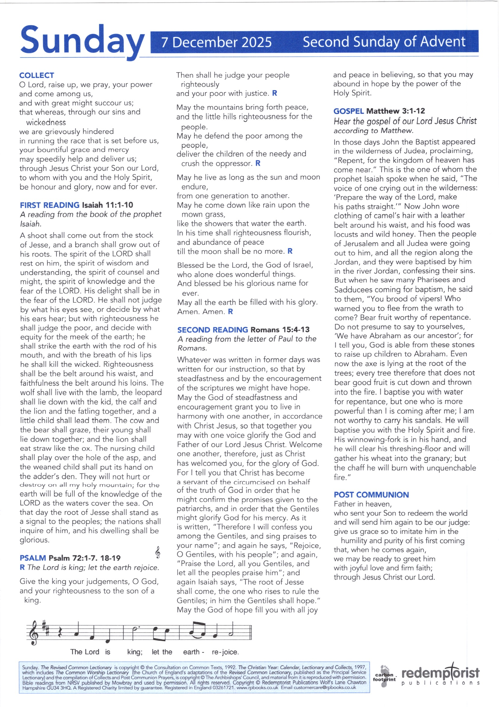

1. Advent candles tell their story
As we watch and pray,
Longing for the Day of Glory,
‘Come, Lord, soon,’ we say.
Pain and sorrow, tears and sadness
Changed for gladness
On that day.

2. Prophet voices loudly crying,
Making pathways clear,
Glimpsing glory, self-denying,
Calling all to hear.
Through their message – challenged, shaken –
Hearts awaken:
God is near!

3. John the Baptist, by his preaching
And by water poured,
Brought to those who heard his teaching
News of hope restored:
‘Keep your vision strong and steady,
And be ready
For the Lord.’

Advent candles tell their story
as we watch and pray,
longing for the Day of Glory,
’Come, Lord, soon,’ we say.
Pain and sorrow, tears and sadness
changed for gladness on that Day.

Mary’s gift, beyond all telling,
was to give Christ room.
Timeless God as human dwelling
in a mother’s womb.
Who could guess the final story? –
cross and glory; empty tomb!

Advent candles tell their story
on this Christmas Day.
Those who waited for God’s glory:
they prepared the way.
Christ is with us: loving, giving,
in us living, here today!

